
Question Bank (2nd IA)
Subject: Biology for Engineers
Subject Code: BBOC407
- Brain functions as a CPU system. Justify.
Ans. The human brain can be thought of as a highly sophisticated and complex information processing system, similar to a computer's Central Processing Unit (CPU). Both the brain and CPU receive and process inputs, store information, and perform calculations to produce outputs. However, there are significant differences between the two, such as the way they store and process information and the fact that the human brain has the ability to learn and adapt, while a computer's CPU does not. Additionally, the human brain is capable of performing tasks such as perception, thought, and emotion, which are beyond the scope of a computer's CPU.

Table: Comparison Chart Basis for Comparison | Brain | Computer
Computer | Neurons and synapses | ICs, transistors, diodes, capacitors, transistors, etc
Memory growth | Increases each time by  connecting synaptic links | Increases by adding more memory chips
Backup systems | Built-in backup system | Backup system is constructed  manually
Memory power | 100 teraflops (100 trillion  calculations/seconds) | 100 million megabytes
Memory density | 107 circuits/cm3 | 1014 bits/cm3
Energy consumption | 12 watts of power | Gigawatts of power
Information storage | Stored in electrochemical and electric impulses. | Stored in numeric and symbolic form (i.e. in binary bits).
Size and weight | The brain's volume is 1500  cm3 and weight is around 3.3  pounds. | Variable weight and size form  few grams to tons.
Transmission of  information | Uses chemicals to fire the  action potential in the neurons. | Communication is achieved  through electrical coded signals.
Information processing  power | Low | High
Input/output equipment | Sensory organs | Keyboards, mouse, web  cameras, etc.
Structural organization | Self-organized | Pre-programmed structure

- What is electroencephalogram (EEG)? Discuss the various applications of electroencephalogram.
Ans. EEG stands for electroencephalography, which is a non-invasive method for measuring the electrical activity of the brain. An EEG records the electrical signals generated by the brain's neurons as they communicate with each other. The signals are recorded through electrodes placed on the scalp and the resulting EEG pattern provides information about the synchronized electrical activity of large populations of neurons.
Applications of EEG
Some of the most common applications of EEG are:
• Diagnosis of Epilepsy: EEG is a widely used tool to diagnose epilepsy and other seizure disorders. It can detect abnormal electrical activity in the brain, which can help to confirm the diagnosis and determine the location of the seizure focus.
• Sleep Studies: EEG is often used in sleep studies to evaluate sleep patterns an diagnose sleep disorders.
• Brain-Computer Interfaces (BCI): EEG can be used to control external devices such as prosthetic limbs or computer software. This is done by detecting specific brain waves associated with a particular mental state, such as concentration or relaxation.
• Research on Brain Function: EEG is used in research to study brain function during various activities such as reading, problem-solving, and decision-making. EEG can also be used to investigate how the brain responds to stimuli such as light, sound, and touch.
• Diagnosis of Brain Disorders: EEG can be used to diagnose a wide range of brain disorders including dementia, Parkinson's disease, and traumatic brain injury.
• Anesthesia Monitoring: EEG can be used to monitor the depth of anesthesia during surgery to ensure that the patient remains in a safe and comfortable state.
• Monitoring Brain Activity during Coma: EEG is also used to monitor brain activity in patients who are in a coma to determine the level of brain function and assess the likelihood of recovery.

- With a neat diagram of neuron explain the process of signal transmission.
Ans. Signal transmission in the brain occurs through the firing of nerve cells, or neurons. A neuron receives inputs from other neurons at its dendrites, integrates the information, and then generates an electrical impulse, or action potential, that travels down its axon to the synaptic terminals. At the synaptic terminals, the neuron releases chemical neurotransmitters, which cross the synaptic gap and bind to receptors on the postsynaptic neuron, leading to the initiation of another action potential in the postsynaptic neuron.
This process of transmitting information from one neuron to another is known as synaptic transmission and forms the basis of communication within the brain. Different types of neurotransmitters have different effects on postsynaptic neurons, and the balance of neurotransmitter levels can influence brain function, including mood, learning, and memory. Signal transmission in the brain is also influenced by various forms of synaptic plasticity, including long-term potentiation (LTP) and long-term depression (LTD), which can modify the strength of synaptic connections and contribute to learning and memory processes.

- Give an account on the structure and functioning of kidneys.
Ans. Architecture of Kidney
The kidney is composed of functional units called nephrons, which are the basic structural and functional units of the kidney. Each kidney contains approximately one million nephrons, and each nephron performs the functions of filtration, reabsorption, and secretion.
The nephron is comprised of several key structures:
• Bowman's capsule: This is a cup-shaped structure that surrounds the glomerulus and filters waste and excess fluid from the bloodstream into the renal tubule.
• Glomerulus: A network of tiny blood vessels within the Bowman's capsule that filters waste and excess fluid from the bloodstream.
• Proximal convoluted tubule: A segment of the renal tubule that reabsorbs important substances, such as glucose, amino acids, and electrolytes, back into the bloodstream.
• Loop of Henle: A U-shaped segment of the renal tubule that is critical for the reabsorption of ions and water.
• Distal convoluted tubule: A segment of the renal tubule that regulates the levels of electrolytes and other important substances in the bloodstream.
• Collecting duct: A series of ducts that collect the filtrate from the renal tubules and transport it to the renal pelvis, where it drains into the ureter and eventually into the bladder.
The nephrons are surrounded by a network of blood vessels, including the afferent arteriole and the efferent arteriole, which bring blood into and out of the glomerulus, respectively. The filtrate produced by the nephron passes through the renal tubules, where it is modified by reabsorption and secretion, before being eliminated from the body as urine.
The mechanism of filtration in the kidneys is a complex process that involves multiple steps to remove waste and excess fluids from the bloodstream. The following is a summary of the steps involved in the filtration process:

  - Blood enters the kidney through the renal arteries and flows into tiny filtering units called glomeruli.
  - At the glomerulus, the pressure in the blood vessels causes a portion of the plasma and dissolved substances to filter out and enter a structure called Bowman's capsule.
  - In Bowman's capsule, the filtrate is then transferred into the renal tubules, which are the main filtering units of the kidneys.
  - In the renal tubules, the filtrate passes through a series of specialized cells, such as proximal tubular cells and distal tubular cells, which reabsorb important substances such as glucose, amino acids, and electrolytes back into the bloodstream.
  - At the same time, the renal tubules secrete waste products, such as urea and creatinine, back into the filtrate.
  - Finally, the filtered fluid, now known as urine, is transported through the renal pelvis and ureters to the bladder, where it is eventually eliminated from the body.
This process of filtration, reabsorption, and secretion helps to maintain the proper balance of fluids and electrolytes in the body, as well as to remove waste and excess substances.

- Lungs are an effective purification system. Justify the statement highlighting the functioning of the lungs.
Ans.

Ans.
The architecture of the lung is designed to maximize surface area for efficient gas exchange. The lung is divided into several parts, including the trachea, bronchi, bronchioles, and alveoli.
Trachea: The trachea is the main airway that leads from the larynx (voice box) to the lungs. It is lined with cilia and mucus-secreting glands that help to filter out harmful substances and trap them in the mucus.

Bronchi: The trachea branches into two main bronchi, one for each lung. The bronchi are larger airways that continue to branch into smaller airways called bronchioles.
Bronchioles: The bronchioles are smaller airways that eventually lead to the alveoli. They are surrounded by tiny air sacs called alveoli, which are the sites of gas exchange.
Alveoli: The alveoli are tiny air sacs that are lined with a network of capillaries. This close proximity of the alveoli and capillaries allows for efficient diffusion of oxygen and carbon dioxide between the air in the alveoli and the bloodstream.
The gas exchange mechanism in the lung involves the transfer of oxygen from the air in the alveoli to the bloodstream, and the transfer of carbon dioxide from the bloodstream to the air in the alveoli. This process is known as diffusion and occurs due to differences in partial pressures of oxygen and carbon dioxide.
  - Oxygen Diffusion: The partial pressure of oxygen in the air in the alveoli is higher than the partial pressure of oxygen in the bloodstream. This difference creates a gradient that causes oxygen to diffuse from the alveoli into the bloodstream, where it binds to hemoglobin in red blood cells to form oxyhemoglobin.
  - Carbon Dioxide Diffusion: The partial pressure of carbon dioxide in the bloodstream is higher than the partial pressure of carbon dioxide in the air in the alveoli. This difference creates a gradient that causes carbon dioxide to diffuse from the bloodstream into the alveoli, where it is exhaled.

- What are stents? Give an account on the stent design and materials used for the manufacturer of stents.
Ans. Stents are small, metal mesh devices that are used to treat blockages in blood vessels. They are typically used in procedures such as angioplasty, where a balloon catheter is used to open up a blocked blood vessel and a stent is placed to keep it open.
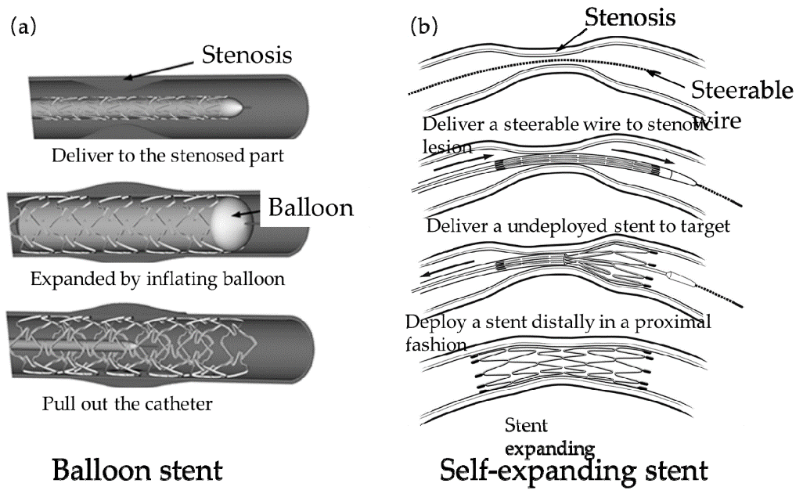
The design of stents can vary depending on the type of stent and the specific medical condition it is used to treat. Some common design features of stents include:
Shape: Stents can be designed in a variety of shapes, including cylindrical, helical, and spiralled, to match the shape of the blood vessel and provide adequate support.
Material: Stents can be made of different materials, including stainless steel, cobalt chromium, and nitinol (a type of metal that is flexible and can return to its original shape after being expanded).
Coating: Stents can be coated with different materials to prevent blood clots from forming and reduce the risk of restenosis (recurrent blockage of the blood vessel).
Expansion mechanism: Stents can be designed to expand in different ways, such as by balloon inflation or self-expansion, depending on the type of stent and the specific medical condition it is used to treat.
Overall, the design of stents plays an important role in their effectiveness and safety. Stents must be designed to provide adequate support to the blood vessel, prevent restenosis, and minimize the risk of complications such as blood clots.

- Give an account on the parts and features of human eye.
Ans.
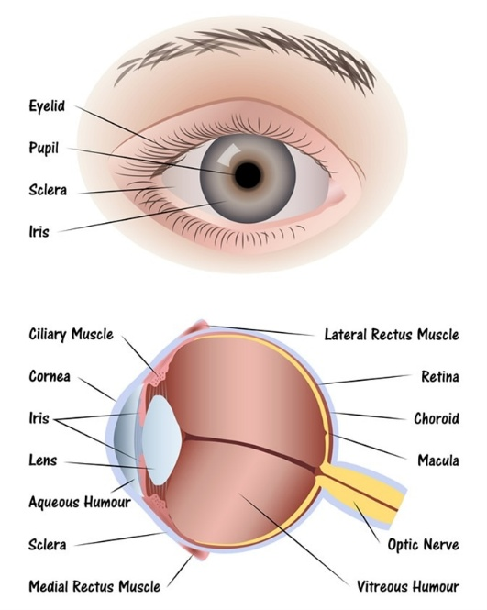
Parts of the Human Eye
• Sclera: The outer covering of the eye is called the sclera. It is a protective tough white layer (white part of the eye).
• Cornea: The transparent part in front of the sclera is called the cornea. Light enters the eye through the cornea, it bends(refracts) the light passes through it. It also protects the eye and also doesn't allow foreign particles to enter the eye.
• Iris: It is a dark, muscular tissue and ring-like structure present behind the cornea. The colour of the eye is due to the colour of the iris. The iris regulates the amount and intensity of light entering the eyes by adjusting the size of the iris.
• Pupil: The pupil is a small opening in the iris. The iris controls the size of the pupil. The pupil’s function is to adjust the amount of light entering the eye.
• Lens: The transparent portion situated behind the pupil is called the lens (convex lens which thicker at the center than the edges). It focusses all the light at one point. The lens alters the shape to focus light on the retina, with the help of ciliary muscles. It becomes small to focus on objects at a distance and becomes big to focus on nearby objects.
• Retina: It’s the inner boundary of the eye. It is the light-sensitive layer that consists of nerve cells. Its function is to convert the images formed by the lens into electrical impulses. These electrical impulses are then transmitted through optic nerves to the brain.
• Optic Nerves: Light coming from retina is sensed by the nerve cells. You can find two types of optic nerves, which are cones and rods.
1. Cones: Cones are the nerve cells that are more sensitive to bright light. Cones help in central and colour vision.
2. Rods: Rods are the nerve cells that are more sensitive to dim lights. Rodes help in peripheral vision.
The message or sensation is then transferred to the brain along the optic nerve.

- Heart is an effective pump. Justify
Ans. The human heart functions as a powerful and efficient pump that maintains continuous circulation of blood throughout the body. It is a muscular, four-chambered organ that plays a vital role in the circulatory system.

Key Features That Make the Heart an Effective Pump:
- Muscular Structure:
  - The walls of the heart, especially the left ventricle, are made of cardiac muscle, which is strong and capable of contracting with great force to push blood throughout the body.
- Chambered Design:
  - The heart has four chambers: the right atrium, right ventricle, left atrium, and left ventricle.
  - The atria receive blood, and the ventricles pump it out, ensuring separation of oxygenated and deoxygenated blood.
- Valves to Prevent Backflow:
  - The tricuspid valve, bicuspid (mitral) valve, pulmonary valve, and aortic valve ensure unidirectional flow of blood and prevent backflow.
- Double Circulation:
  - The heart supports double circulation:
    - Pulmonary circulation (right side): Pumps deoxygenated blood to the lungs.
    - Systemic circulation (left side): Pumps oxygenated blood to the rest of the body.
- Electrical Coordination:
  - The sinoatrial (SA) node acts as the natural pacemaker, sending electrical impulses that coordinate heartbeats and ensure rhythmic pumping.
- Adaptability:
  - The heart can adjust the rate and strength of contractions based on the body’s needs (e.g., during exercise or rest).
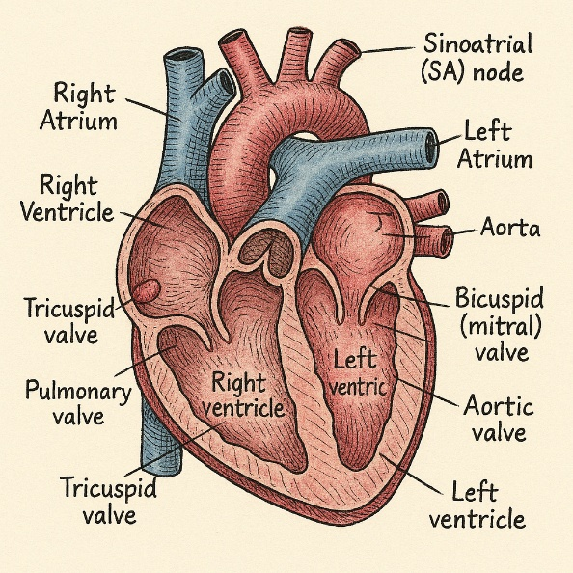

Labeled Diagram of the Human Heart

- What is ECG? Discuss the type of heart activities detected using ECG.
Ans. The heart's pumping action is controlled by electrical signaling, which generates the rhythm of the heartbeat. This electrical signaling can be monitored using an electrocardiogram (ECG), which records the electrical activity of the heart and provides important information about the heart's function.
An ECG measures the electrical signals produced by the heart as it beats and generates a trace or waveform that reflects the electrical activity of the heart. This trace can be used to diagnose heart conditions and monitor the heart's function.
Some common heart-related issues that can be diagnosed or monitored using an ECG include:
• Arrhythmias: Abnormalities in the heart's rhythm or rate can be detected using an ECG.
• Heart disease: Changes in the heart's electrical activity can indicate the presence of heart disease, such as coronary artery disease or heart attacks.
• Heart attack: An ECG can help diagnose a heart attack by detecting changes in the heart's electrical activity that indicate a lack of blood flow to the heart.
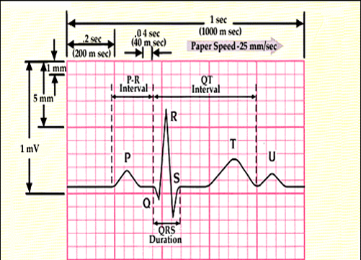
Overall, the ECG is a useful tool for diagnosing and monitoring heart-related issues and helps to provide important information about the heart's function and health.

- What are pacemakers? Explain the basic design and construction of pacemakers.
Ans. A pacemaker is a small device that is surgically implanted in the chest to regulate the heartbeat. It is used to treat heart rhythm disorders, such as bradycardia (a slow heartbeat) or arrhythmias (abnormal heart rhythms), by delivering electrical impulses to the heart to regulate its rhythm.
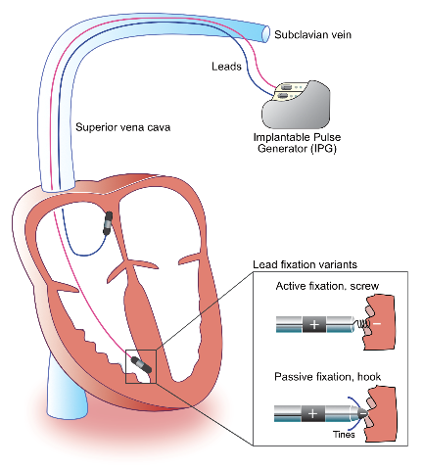
The basic design of a pacemaker consists of:
Generator: The generator is the main component of the pacemaker and contains a battery and electronic circuitry to generate and control the electrical impulses.
Leads: Leads are thin wires that connect the generator to the heart and carry the electrical impulses from the generator to the heart.
Electrodes: The electrodes are located at the end of the leads and are used to deliver the electrical impulses to the heart.
Pacemakers can be designed to work in different ways, including:
Single-chamber pacemaker: A single-chamber pacemaker delivers electrical impulses to either the right atrium or the right ventricle of the heart to regulate its rhythm.
Dual-chamber pacemaker: A dual-chamber pacemaker delivers electrical impulses to both the right atrium and the right ventricle of the heart to regulate its rhythm.
Biventricular pacemaker: A biventricular pacemaker delivers electrical impulses to both ventricles of the heart to coordinate their contractions and improve heart function in people with heart failure.

- What is spirometry? Discuss the types and functioning of the spirometry.
Ans. Spirometry is a pulmonary function test that measures lung capacity and airflow by assessing the volume of air inhaled and exhaled, as well as the speed at which it's expelled. It helps diagnose and monitor various lung conditions like asthma, COPD, and other respiratory issues. Spirometry can be performed using different devices, including basic incentive spirometers, professional-grade spirometers, and digital peak flow meters.
Types of Spirometers:
Basic Incentive Spirometer: These are handheld devices used to encourage deep breathing and lung expansion after surgery or illness, according to CMI Health.
Professional Spirometer: These are more sophisticated devices, often used in clinical settings, and typically measure more parameters than basic incentive spirometers.
Digital Peak Flow Meter: These devices measure the peak expiratory flow rate (PEF), which is the maximum speed at which air can be exhaled.
Digital Smart Spirometers: Some digital spirometers, like SpiroLink, are designed for home use and can measure PEF, FEV1, and other lung function parameters.

Functioning of Spirometry:
1. Preparation: The patient sits upright and is instructed on how to perform the test, which involves a full inhalation and a forceful, rapid exhalation.
2. Forced Exhalation: The patient breathes in deeply, then exhales as forcefully and as quickly as possible into the spirometer.
3. Measurement: The spirometer measures the volume of air exhaled at different time points and graphs the results.
4. Analysis: Key parameters, such as forced vital capacity (FVC), forced expiratory volume in one second (FEV1), and the FEV1/FVC ratio, are calculated from the graph.
5. Interpretation: The results are compared to normal values for the patient's age, gender, and height to determine if there are any abnormalities in lung function.
Spirometry is a crucial tool for diagnosing and monitoring respiratory conditions, helping healthcare professionals understand the extent of airflow limitations and track the effectiveness of treatments.

- Explain the architecture of cones and rod cells with suitable diagrams.
Ans.
Rod Cells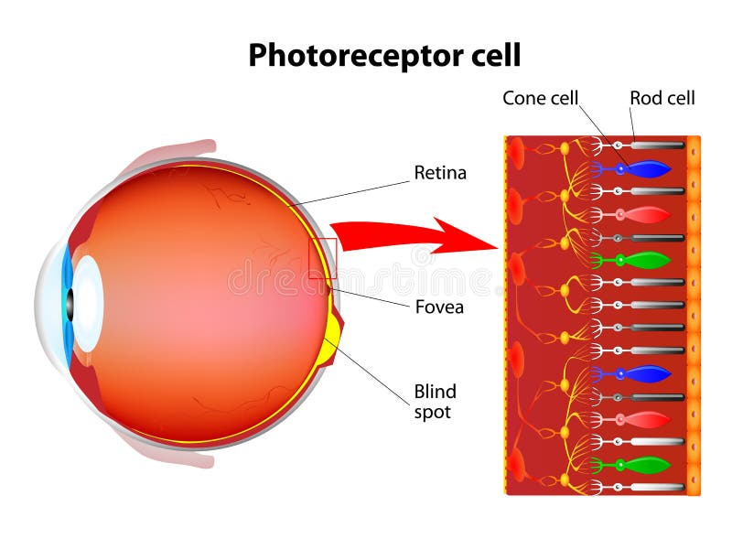
Rod cells are photoreceptor cells in the retina of the eye that are responsible for detecting light and
transmitting signals to the brain for the perception of vision, especially in low light conditions.
They contain a protein called rhodopsin that absorbs light and triggers a chain of events leading to
the activation of neural signals. Rods are more sensitive to light than cone cells but do not
distinguish color as well.
Cone Cells
Cone cells are photoreceptor cells in the retina of the eye that are responsible for color vision and
visual acuity (sharpness of vision). There are three types of cone cells, each containing a different
photopigment sensitive to different wavelengths of light (red, green, and blue), which allow for
the perception of color. Cones are less sensitive to light than rod cells but provide better visual
acuity and color discrimination. They are concentrated in the fovea, the central part of the retina
responsible for detailed and sharp vision.
Architecture
- What is ultrasonography? Explain its uses and working principle.
Ans. Ultrasonography is a medical imaging technique that uses high-frequency sound waves to produce images of the internal organs and tissues of the body. It is also known as ultrasound imaging or sonography.
The ultrasound machine emits high-frequency sound waves (usually in the range of 2 to 18 MHz) that travel through the body and bounce back off of the internal organs and tissues. The returning echoes are captured by the ultrasound machine and used to create images of the internal structures.
Uses of Ultrasonography
Ultrasonography is a versatile imaging method that is used in a wide range of medical applications.
Some of the most common uses of ultrasonography include:
• Obstetrics and gynecology: Ultrasonography is commonly used to monitor the growth and development of a fetus during pregnancy, as well as to evaluate the reproductive organs and female pelvic organs for conditions such as ovarian cysts, fibroids, and endometrial cancer.
• Abdominal imaging: Ultrasonography is used to image the organs of the abdomen, such as the liver, gallbladder, pancreas, spleen, and kidneys, to diagnose conditions such as liver disease, gallstones, pancreatitis, and kidney stones.
• Musculoskeletal imaging: Ultrasonography is used to image the muscles, tendons, and ligaments to diagnose conditions such as muscle strains, tendonitis, and ligament sprains.
• Vascular imaging: Ultrasonography is used to image blood vessels, such as the arteries and veins, to diagnose conditions such as blood clots, blockages, and aneurysms.
• Eye and neck imaging: Ultrasonography is used to image the eyes and neck to diagnose conditions such as cataracts, glaucoma, and thyroid nodules.
• Emergency medicine: Ultrasonography is often used in emergency medicine to quickly and accurately diagnose conditions such as appendicitis, pneumothorax, and fluid buildup in the abdomen or chest.
Working Principle of Ultrasonography
The working principle of ultrasonography is based on the reflection of high-frequency sound waves.
• Transducer: An ultrasonography machine consists of a transducer that is used to emit and receive high-frequency sound waves. The transducer is placed in direct contact with the skin or inserted into the body through a gel.
• Emission of sound waves: The transducer emits high-frequency sound waves (usually in the range of 2 to 18 MHz) into the body. These sound waves travel through the body and encounter different tissues and organs, which have different acoustic properties.
• Reflection of sound waves: The sound waves encounter boundaries between different tissues and organs and bounce back, creating echoes. The strength of the echoes depends on the acoustic properties of the tissues and organs, such as density and stiffness.
• Reception of echoes: The transducer in the ultrasonography machine receives the echoes and sends the information to a computer, which processes the data to create images.
• Image formation: The computer uses the information from the echoes to create images of the internal organs and tissues of the body. The images are displayed on a screen, allowing the operator to see the structure and movement of the internal organs and tissues.

- Differentiate between Biological & technological echolocation.
Ans. Echolocation is a biological or technological process that involves emitting sound waves and listening to the echoes that bounce back off of objects in the environment to determine their location, distance, and shape.
A comparison of biological echolocation and technological echolocation is given below:
Biological Echolocation
• Found in various animals such as bats, dolphins, and some species of whales.
• Relies on the emission of sound waves, usually in the form of clicks or vocalizations.
• Animals emit sound waves and listen for the echoes produced when the sound waves bounce off objects in their environment.
• By analyzing the echoes, animals can determine the location, distance, and even the shape of objects around them.
• This ability is mainly used for navigation, hunting, and communication in the animal kingdom.
• Biological echolocation is a natural adaptation that has evolved over millions of years.
Technological Echolocation
• Replicates the concept of biological echolocation using technological devices.
• Utilizes sound waves, typically generated by artificial sources such as sonar or ultrasonic sensors.
• These devices emit sound waves and analyze the echoes that bounce back from objects.
• The information from the echoes is processed and interpreted by the technology to generate useful data, such as distance, location, and object recognition.
• Technological echolocation has applications in various fields, including navigation, robotics, obstacle detection, and medical imaging.
• It is a human-engineered solution inspired by the natural abilities of animals.

- What is lotus leaf effect? Explain the mechanism and application of super hydrophobic effect.
Ans. The lotus leaf effect, also known as the "lotus effect," refers to the ability of lotus leaves to repel water and self-clean through their unique surface structure. This effect has inspired the development of super hydrophobic and self-cleaning surfaces, which have a wide range of applications in various industries.
The lotus leaf surface has a microscale and nanoscale structure that consists of numerous small bumps and wax-coated hairs. This structure creates a high contact angle between the water droplets and the surface, causing the droplets to roll off and carry away any dirt or debris. This self-cleaning property is due to the lotus leaf's ability to repel water and resist adhesion.

The mechanism of Super hydrophobic Surfaces
The super hydrophobic effect refers to the ability of certain surfaces to repel water and resist wetting. Super hydrophobic surfaces are characterized by a high contact angle between water droplets and the surface, typically over 150 degrees, and a low contact angle hysteresis, meaning that the droplets roll off the surface with ease.
Figure: Representing super hydrophobic and super hydrophilic effects

The super hydrophobic effect is achieved through the use of various techniques. These techniques create a surface structure that traps air between the surface and the water droplets, reducing the contact area between them and making it more difficult for the droplets to wet the surface.
Engineering Applications of Super Hydrophobic Surfaces
Super hydrophobic surfaces have potential applications in the electronics, automobile, and aerospace industries, offering several benefits in these sectors. Here are some specific applications:
Electronics Industry:
• Waterproofing Electronics: Super hydrophobic coatings can protect electronic components from water damage. By applying super hydrophobic coatings on circuit boards, connectors, and other sensitive electronic parts, water ingress can be minimized, improving the reliability and durability of electronic devices.
• Moisture Resistance: Electronic devices exposed to humid environments or moisture- prone conditions can benefit from super hydrophobic coatings. These coatings prevent moisture from reaching critical electronic components, reducing the risk of short circuits, corrosion, and malfunction.
• Self-Cleaning Displays: Super hydrophobic coatings applied to displays and touch screens repel water, oils, and fingerprints, making them easier to clean and maintain. This improves the visibility and functionality of electronic displays, especially in outdoor or high-touch applications.
Automobile Industry:
• Anti-Fogging Windows and Mirrors: Super hydrophobic coatings can be used on
automobile windows and mirrors to prevent fogging or condensation formation. The water-repellent property helps maintain clear visibility, enhancing driver safety and comfort in humid or cold weather conditions.
• Self-Cleaning Surfaces: Applying super hydrophobic coatings to the exterior surfaces of vehicles can facilitate self-cleaning by repelling water, dirt, and contaminants. This reduces the need for frequent washing and maintenance, keeping the vehicle cleaner and improving its appearance.
• Fuel Efficiency: Super hydrophobic coatings can reduce drag and frictional resistance on vehicle surfaces, leading to improved aerodynamics and fuel efficiency. By minimizing
water adhesion, the coatings help reduce the accumulation of water droplets on the vehicle's exterior, decreasing drag and optimizing performance.
Aerospace Industry:
• Anti-Icing and Deicing: Super hydrophobic coatings applied to aircraft surfaces can prevent ice formation or facilitate ice removal. This is particularly important for critical areas such as wings, engine components, and sensors, helping to ensure safe operations and reducing the risk of ice-related incidents.
• Drag Reduction: Super hydrophobic coatings on aircraft surfaces can minimize frictional drag during flight, leading to improved fuel efficiency and reduced emissions. The water- repellent property helps maintain a smooth airflow over the surface, optimizing aerodynamic performance.
• Corrosion Resistance: Super hydrophobic coatings can protect aerospace components from corrosion caused by exposure to moisture, rain, or harsh environments. By repelling water and reducing surface contact with corrosive agents, these coatings help preserve the structural integrity and lifespan of aerospace equipment.

